SERVICE ORIENTATION WORKSHOP!

AUGUST 27TH FROM 2PM TO 4:30PM

FOOD AND SNACKS WILL BE PROVIDED

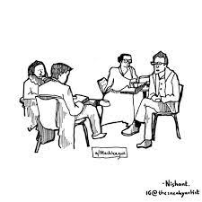

JOIN US AND LEARN ABOUT SERVICE POSITIONS

EDI CLUB 18 W STREAMWOOD BLVD, STREAMWOOD, IL 60107

HOSTED BY AREA 20 AND DISTRICT 23